**Setup Steps:**

1. Download and Install Node.js and npm.( [Node.js — Download Node.js®](https://nodejs.org/en/download/))



1. Install a code editor or IDE.( I recommend vs code)

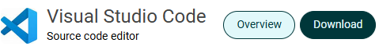

1. Install Create React App using npm or yarn.(recommend npm coz that’s what I use) note: sometimes, npm would have been installed when installing node.js

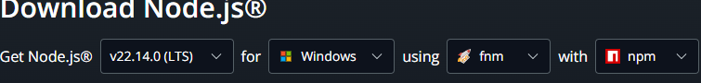



1. Check if the installation was successful:

Go to the terminal. And type: node -v

it should show the version number



Also type npm to check if the npm was installed successfully:

it should show the version number



4. Your environment is set to go, go to the next stage on creating a react-app.